*November 14, 2024*

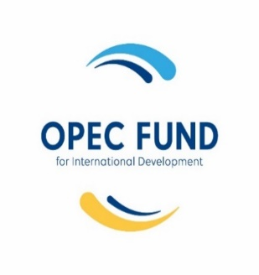

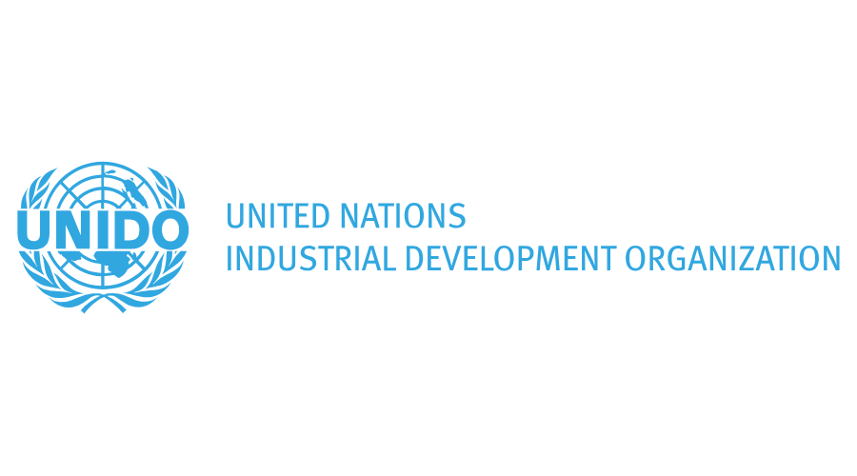

COP 29 Side Event:   
ADVANCING Clean cooking -Financing & PARTNERSHIPS

**High Level Panel: Financing for Scaling Clean Cooking**

**Date:** 14 November 2024

**Time:**  15h45-16h45 (AZT)

**Venue:** UNIDO Pavilion

**Organizers:** Vice-President Office, Tanzania, Department of Environment,

UNIDO-Council on Ethanol Clean Cooking, and Climate Finance & Energy Innovation Hub

**Facilitator of the Event**: Mr. Mikael Melin, Head, People Centred Programmes, SEforALL

**AGENDA**

**A. Background and Context**

H.E. Samia Suluhu Hassan, President of the United Republic of Tanzania, in collaboration with other high-level dignitaries, launched the African Women Clean Cooking Support Programme (AWCCSP) on the side-lines of the Conference of Parties (COP) 28 held in Dubai, United Arab Emirates, in 2023. The programme targets African women, as they bear the impacts of using traditional fuel to cook the most. This ground breaking initiative led global actors in the clean cooking space to organize the Summit on Clean Cooking in Africa.

The clean cooking summit was hosted by the International Energy Agency (IEA) in Paris in May 2024 and co-chaired by leaders of Tanzania and Norway, alongside the African Development Bank. The summit was able to raise commitments from various partners, governments, and donor agencies to the tune of USD 2.2 billion to generate the $4 billion annual capital investments required until 2030 to achieve universal access to clean cooking in sub-Saharan Africa.

Similarly, OPEC Fund, IRENA, SEforAll and UNIDO led Climate Finance Energy and Innovation Hub, which intends to mobilize financing for clean cooking to developing countries.

**B. Objective of the event**

In this context, the Government of Tanzania, in collaboration with UNIDO and is jointly organizing this side event to highlight its recently launched National Clean Cooking Energy Strategy. The strategy provides a roadmap for the country to meet its target of accelerating 80 percent of its population to clean cooking solutions by 2034 and various partnerships developed to achieve the goals set.

**C. Participants**

In this high-level session, Ministers from Madagascar, Cote d’Ivoire and Tanzania will join UNIDO and OPEC Fund to reiterate the call for channelling financing for scaling clean cooking in African countries.

**D. Format**

**The first session** will feature a high-level panel with goodwill messages from global partners to lend their support to the ground breaking initiative (AWCCSP) championed by H.E. Samia Suluhu Hassan, President of the United Republic of Tanzania.

**E. Languages**

The presentations and interventions shall be made in either English or French.

**F**. **Setting**

The opening session is 45 minutes structured as follows:

|  |  |
| --- | --- |
| Time | Agenda |
| 15: 45 - 15:47 | **Welcome and introduction**  **Moderated by:** Mikael Melin |
| 15:47 - 15:55 | **Keynote Speech:**  H.E. Dr. Ashatu KIJAJI, Minister of State, Vice President Office, United Republic of Tanzania Tanzanian Government |
| 15:55 – 16:25 | **Goodwill message and Interventions by speakers:**   * **Mr. Jacques Assahore Konan**, Minister of Environment and Sustainable Development, Cote D’Ivoire * **Ms. Al Shaimaa AL-SHEIBY**, Vice President, Public Sector Operations & Acting Vice President, Strategy, OPEC Fund * **Mr. Ciyong ZOU**, Deputy to DG and Managing Director, TCS, UNIDO * **Mr. Jinot RAZAFIMAMONJY**, Director of Hydrocarbons, Ministry of Energy and Hydrocarbon Madagascar |
| 16:25- 16:30 | Final summary and wrap-up |

**Session 2 -** S**calling Clean Cooking: Showcasing Partnerships**

**Date:** 14 November 2024

**Time:**  17h00-18h00 (AZT)

**Venue:** UNIDO Pavilion

**A. Background and Context**

Lack of financing is a major impediment in scaling up modern clean cooking solutions. According to the Global Tracking SDG 7 - The Energy Progress Report 2024, an estimated 2.1 billion people still lack access to clean cooking fuels and technologies. While there has been a significant reduction from 2.9 billion in 2010 to 2.3 billion in 2021, it is projected that 1.8 billion people will still be facing cooking energy poverty by 2030. The report highlights that in countries within the Sub-Saharan Africa (SSA) region, access to clean fuels and cooking technologies remains limited, with less than 20% of their population having such access. This highlights the urgent need for collaborative efforts from both the private and public sectors to mobilize the necessary finances to expedite access to modern clean cooking solutions, with an estimated annual cost of US$ 2.4 trillion, considering the impacts of climate change, health, and gender. In addition, according to the IEA, an estimated US$ 8 billion is required annually to accelerate access to clean cooking solutions.

The International Energy Agency (IEA) has estimated that USD 4 billion is required annually to meet the clean cooking target by 2030 in sub-Saharan Africa. However, in previous years, barely USD 50-100 million has been mobilized to address the low access rate to clean cooking solutions. Recent developments in the clean cooking space have indicated growing interest from global actors to prioritize access to clean cooking solutions. This interest culminated in the Summit for Clean Cooking in Africa, organized in Paris in May 2024. The global actors who participated committed to raising financial resources totalling USD 2.2 billion, in addition to the African Development Bank (AfDB)’s commitment of USD 2 billion over the next 10 years. Additionally, the Clean Cooking Declaration: Making 2024 the Pivotal Year for Clean Cooking was adopted.

**B. Objective of the event**

In this context, the Council on Ethanol for Clean Cooking (CECC) and the Climate Finance and Energy Innovation Hub is jointly organizing this side event to show case best practices to mobilize resources to develop national clean cooking strategies, road maps and forge partnerships to implement the strategies or roadmaps.

**C. Format**

The second session is an interactive panel discussion that will highlight the role of partnerships in scaling clean cooking by Senior Officials from Madagascar, Ivory Coast and Tanzania. They will show case their national clean cooking strategies and respond to the questions below

**D. Key Questions**

1. What mechanisms do countries have in place to attract public and private finance to scale up clean cooking solutions in your countries?
2. What are the best practices on coordinating clean cooking action plans/strategies/roadmaps in countries?
3. What innovative financing mechanisms have proven effective in attracting private investments?
4. How does the integrity of carbon credit affect the resource mobilization for clean cooking solution and incentivize private sector investments?

**E. Languages**

The presentations and interventions shall be made in either English or French.

**F**. **Setting**

This panel discussion of 60 minutes structured as follows:

|  |  |
| --- | --- |
| Time | Agenda |
| 17: 00 – 17:07 | **Scene setting by AFREC highlighting Sustainable Scaling: Meeting the Clean Cooking Challenge in Africa report** |
| 17:07 - 17:10 | **Brief introduction of the topic by the Moderator**  Mr. Mikael MELIN, Head, People Centred Programmes, SEforALL |
| 17:10 – 17:40 | **Panellist will highlight the partnerships in their countries:**   * **Mr Gustave ABOUA,** Chair, Council on Ethanol Clean Cooking & DG of Environment and Sustainable Development, Cote D’Ivoire * **Mr. Emilian NYANDA,** Director, Ministry of Energy of Tanzania * **Mr Kenny Marco Louis FIDIARISON,** Director, Ministry of Energy and Hydrocarbons * **Ms. Sophie Odupoy,** Group Head of Public Affairs, KoKo Network * **Ms. Hadiza Abdulmumini**, SDG7 Youth Constituency * **Mr. Kakembo Brian,** Founder- WEYE Clean Energy Company |
| 17:40- 17:50 | An open discussion will follow to respond the key questions. |
| 17:50- 18:00 | Questions from the floor and final summary/wrap-up |